Report of Activities

My Source management started rather late but below I have the source management that I did do starting from the 10th of January continuing until the 22nd of January.

Remote GitHub repository

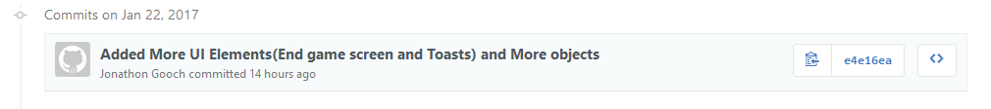

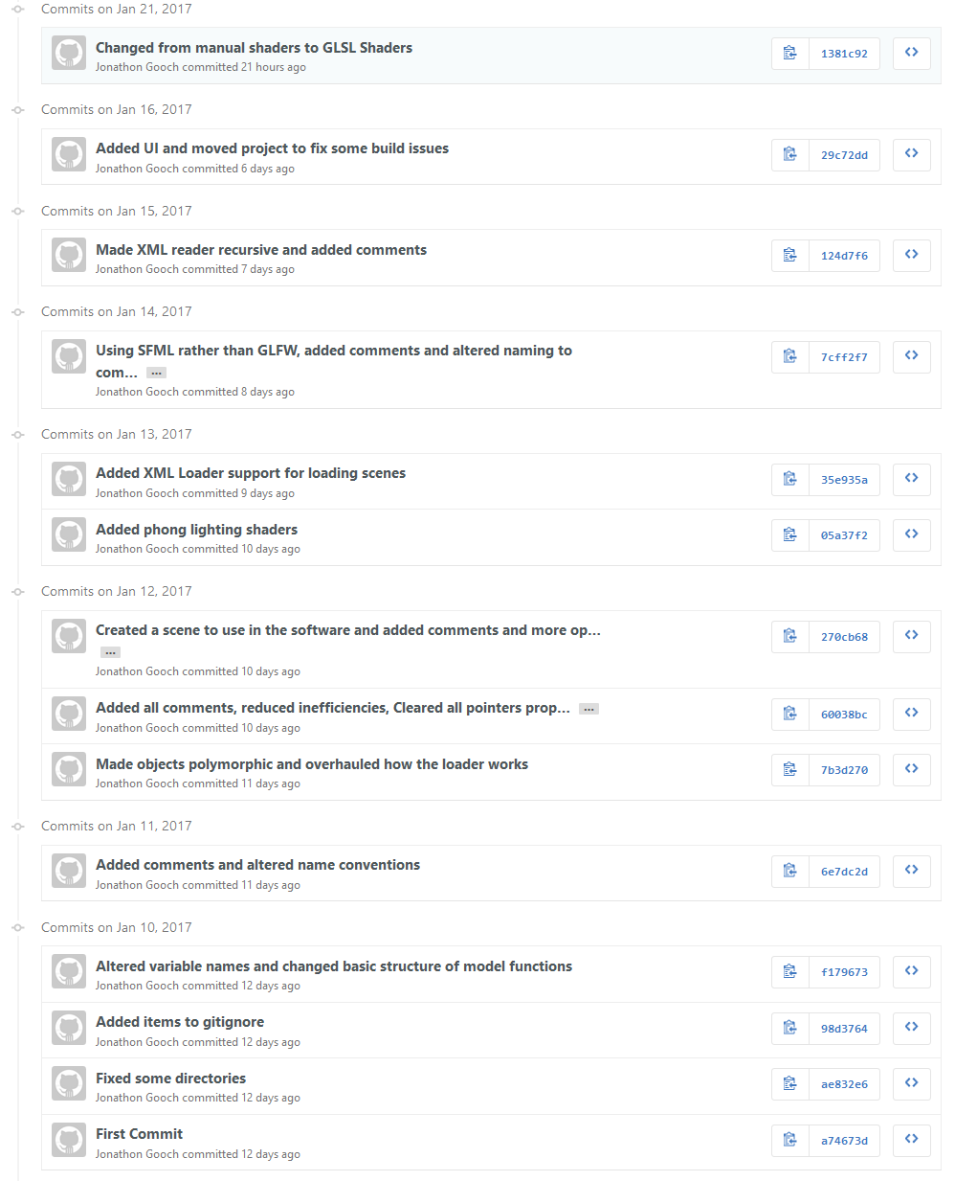

Local Git Repository

